

|  |  |
| --- | --- |
| **ANGELWINGS COMPREHENSIVE COLLEGE, MAROKO, PW, KUBWA, ABUJA** | |
| **THIRD TERM EXAMINATION 2024/2025 ACADEMIC SESSION** | |
| **SUBJECT: LITERACY** | **CLASS: NURSERY TWO** |

(1) Write the upper and lower case letters Aa to Zz. A has already been done as an example

Aa __ __ __ __ __ __ __ __ __ __ __ __ __ __ __ __ __ __ __ __ __ __ __ __ __

(2). Use either full stop or question mark to complete the sentences.

Do you like drawing _

Where are you going _

I am going to the school _

My father is at work _

(3). Use the underlined words to complete the questions.

Who How Why When

_________ is your birthday?

_________ old are you?

_________ are you crying?

(4) Copy the sentences correctly

This is a tree. ________________________________________________

The moon is up. _______________________________________________

This is a girl. _________________________________________________

It is a red dress. ______________________________________________

(5). Color all the nouns red and the verbs blue.

Sit eat goat man

(6). __________________ is an action word.

(7). Read the passage carefully and answer the questions .

This is a village .

Grandmother lives there

Grandfather lives there.

They are at home today.

Complete the sentences.

____________________ and ______________________ live in the village.

Both of them are at __________________ today

(8). Identify the name, then copy and write the name for each fruits

mango apple orange banana

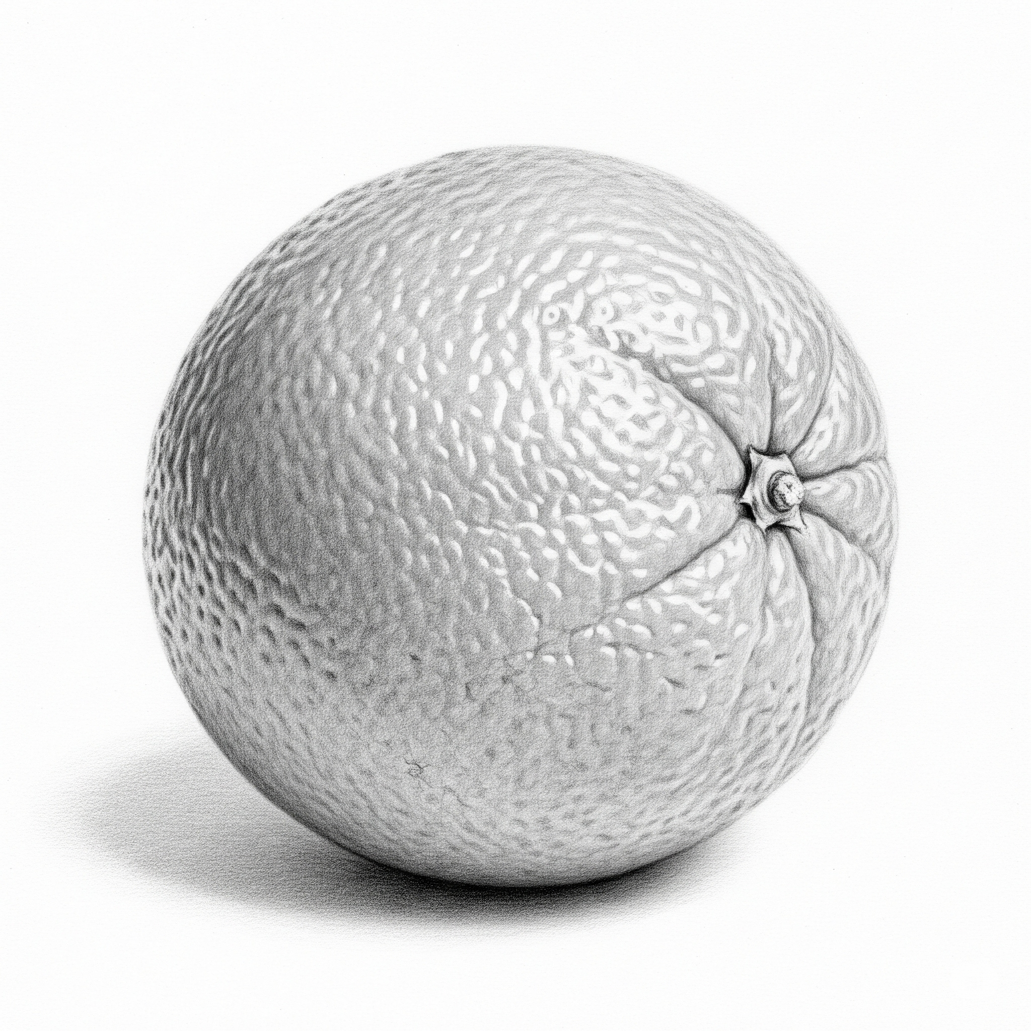 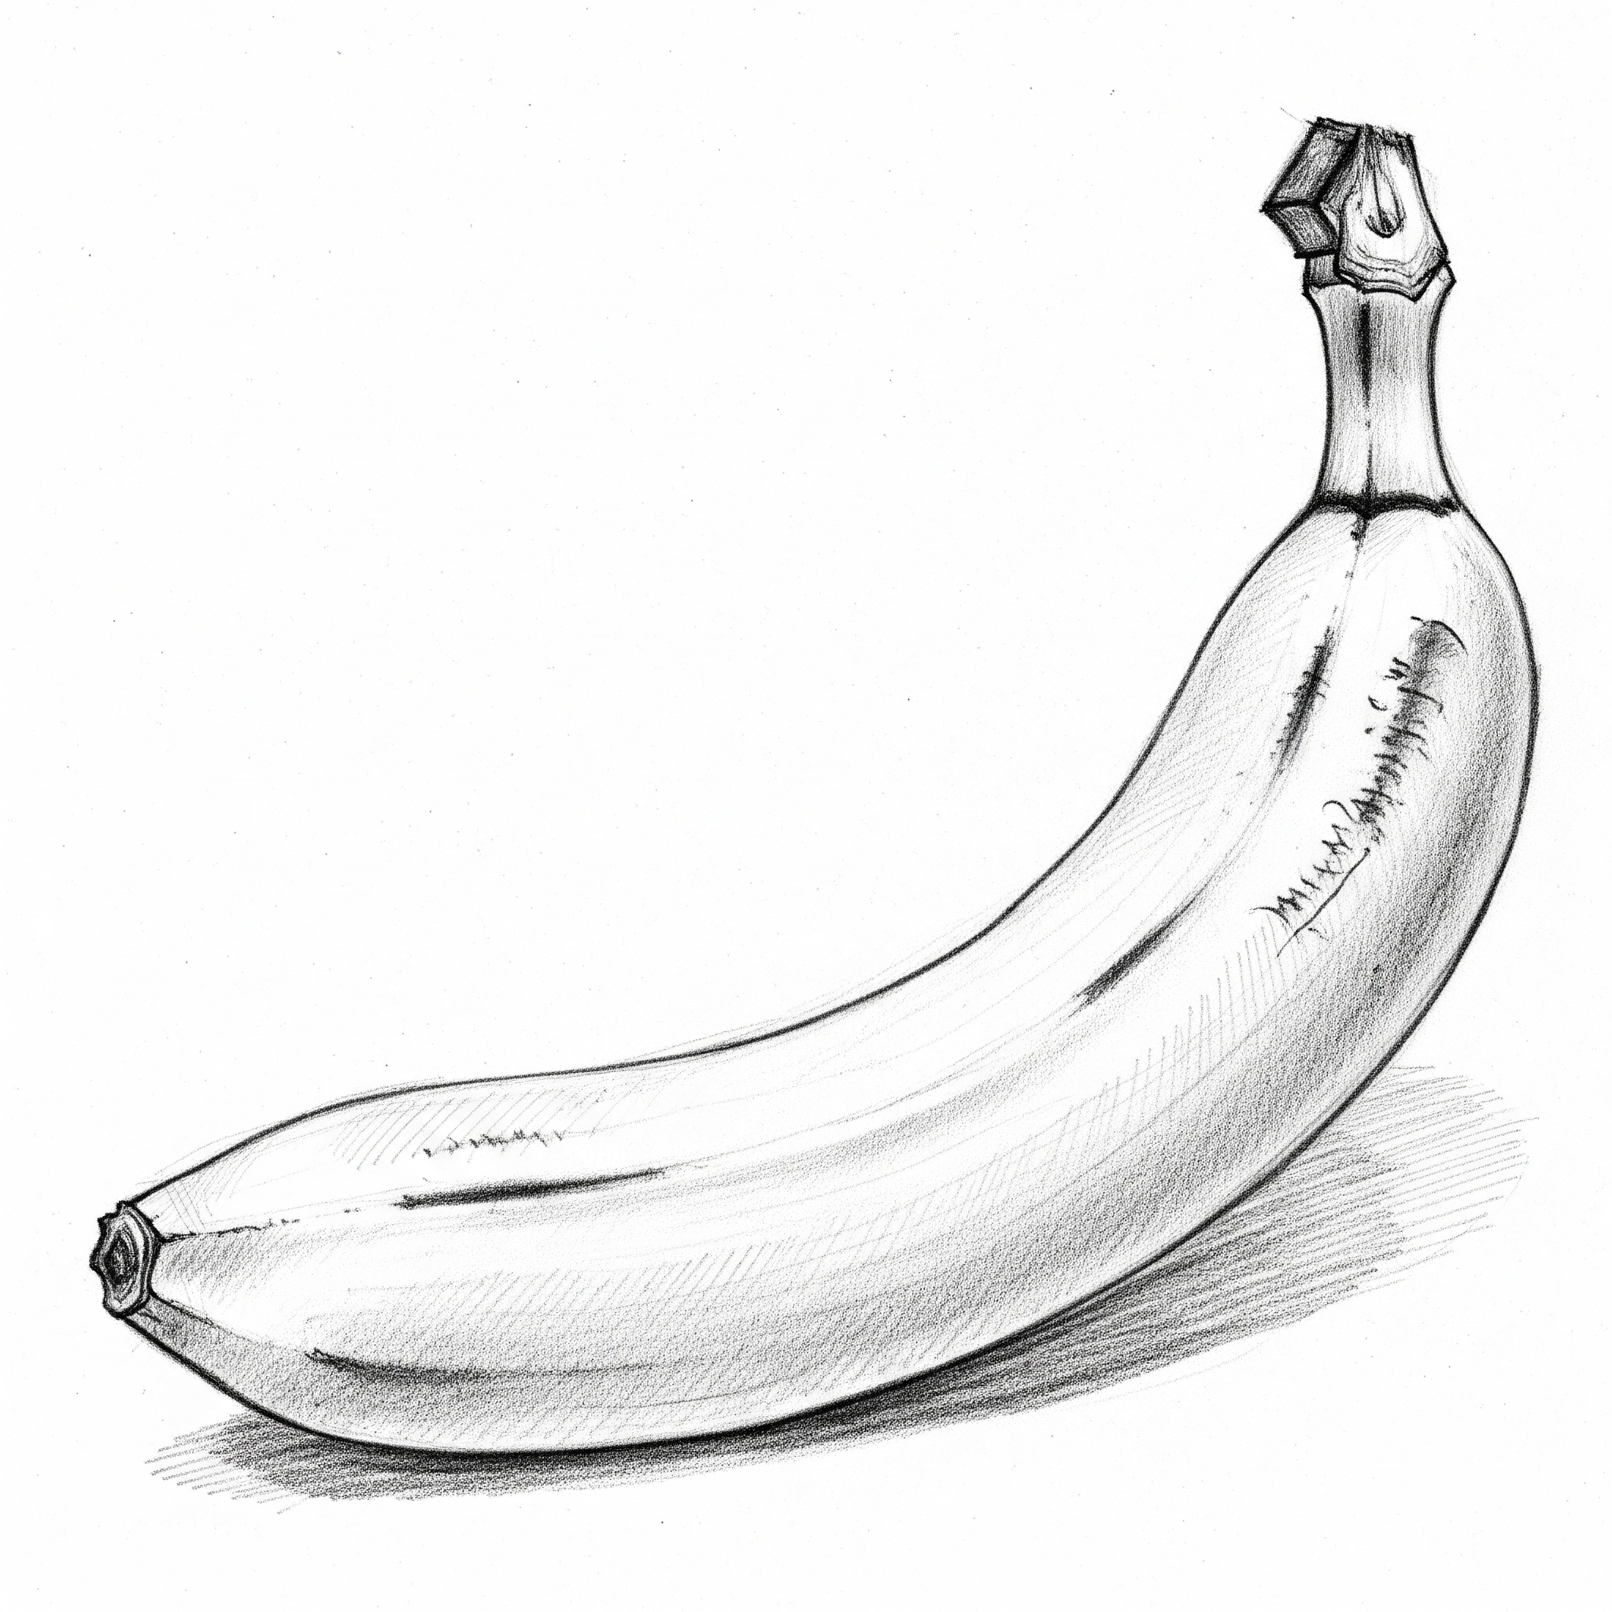 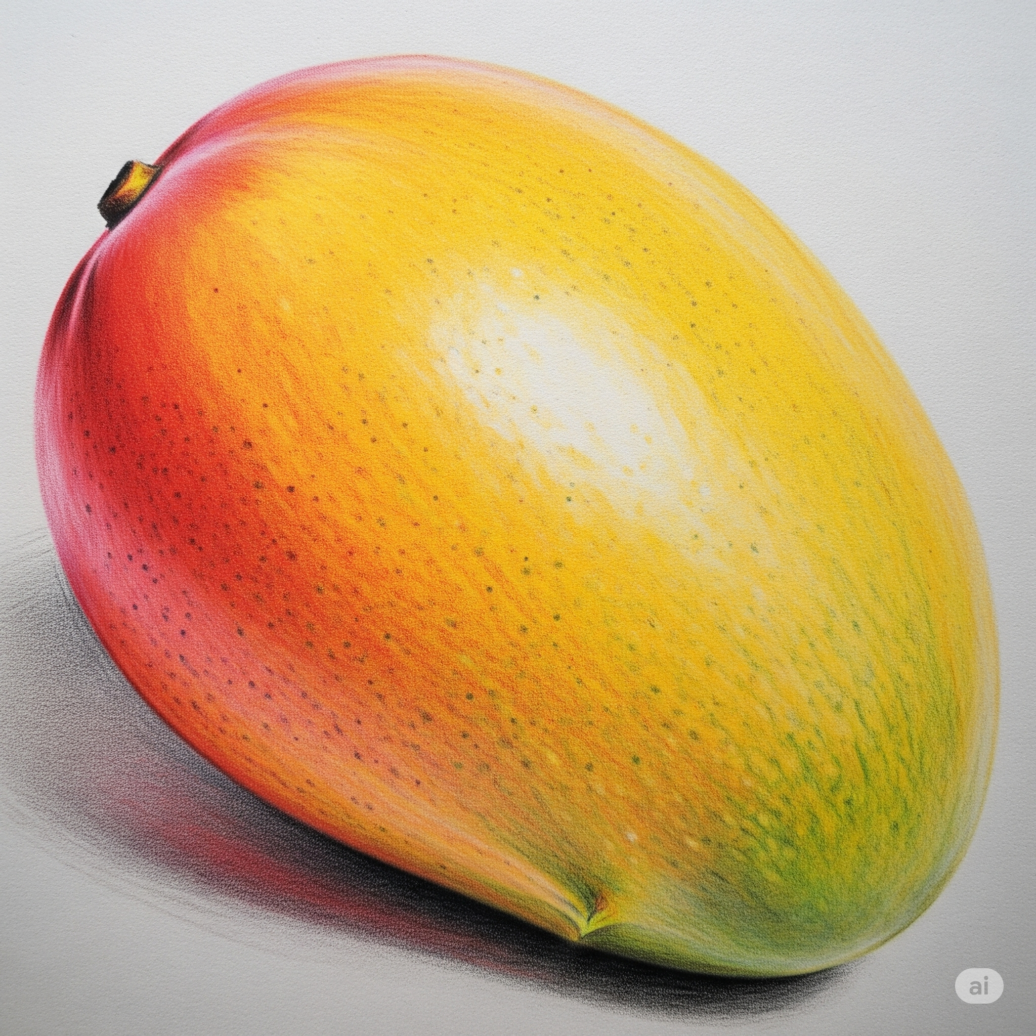 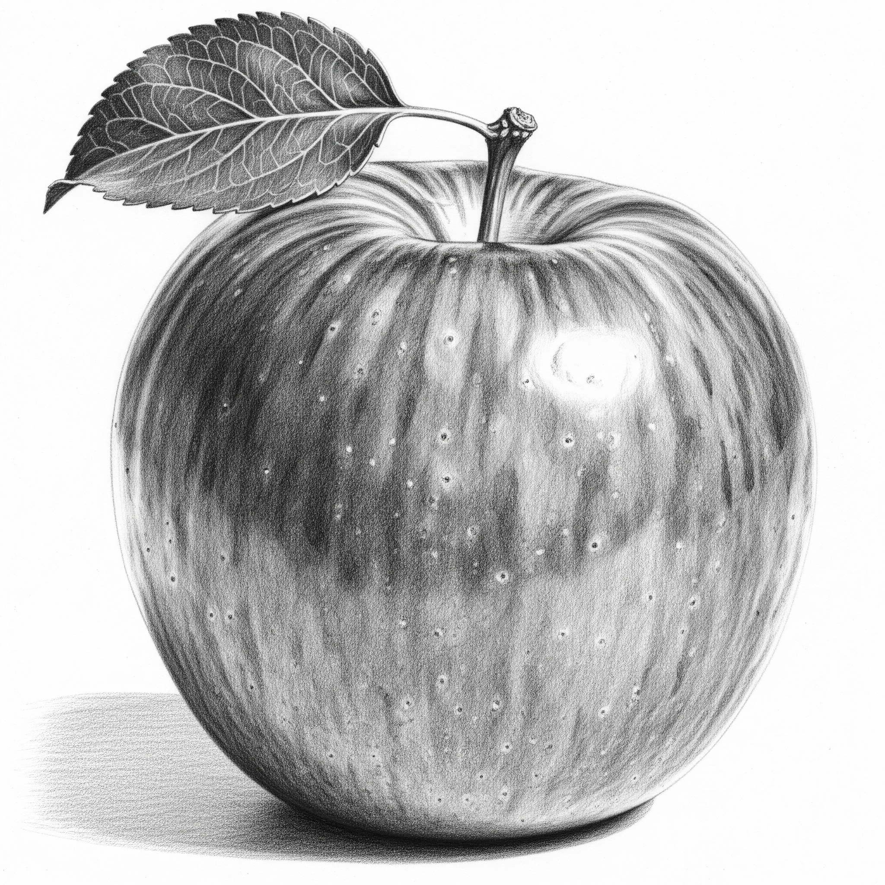

____________ ____________ ____________ ____________

(9). Read

Look at father.

Look at mother.

Father is by the car.

Mother is by the car.

They are going to get in side the car.

Can you see the baby?

(10) Make five short sentences with the following words.

Pencil

___________________________________________________________

Book

___________________________________________________________

Bag

___________________________________________________________

Toy

___________________________________________________________

My self

___________________________________________________________